Digital Chip Design Program
RTL Design
Alia Alsultan
Elaf Alkhalaf
Lana Aldhali
Manar Alnuqaydan

Task #08
14/07/2026

Sequential Datapath Design Part 2

Task #8.1

8.1.1

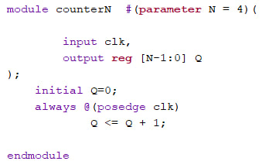

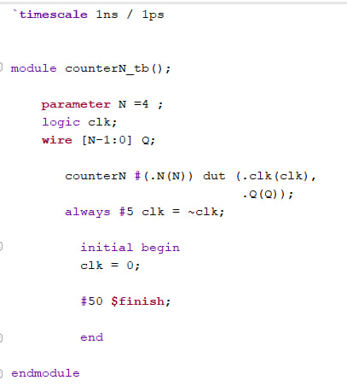

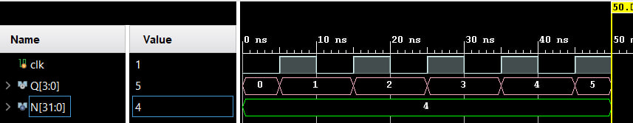

Task #8.2

8.2.1

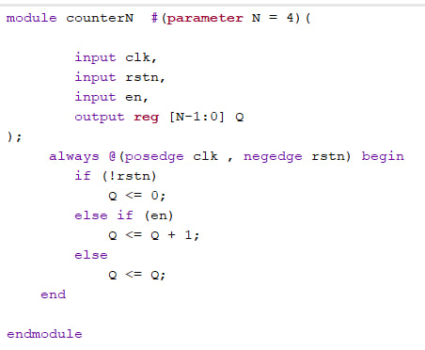

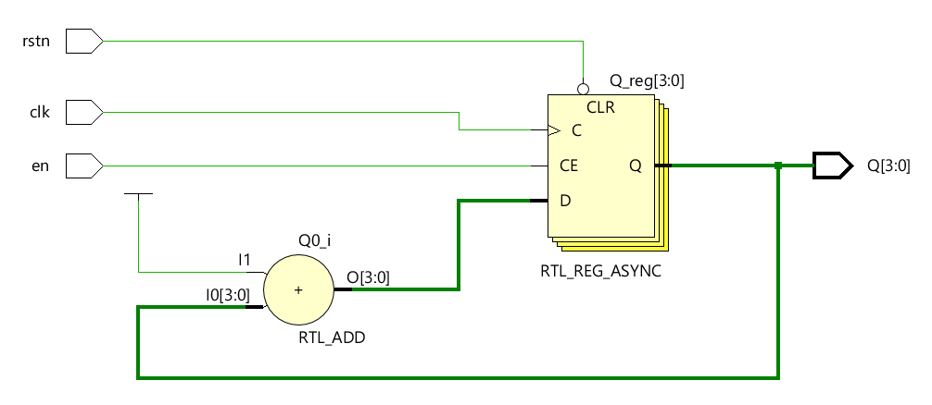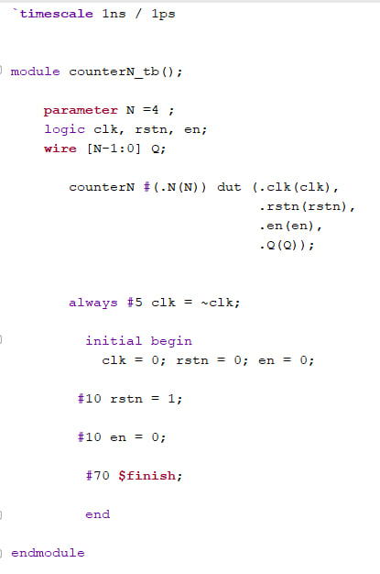

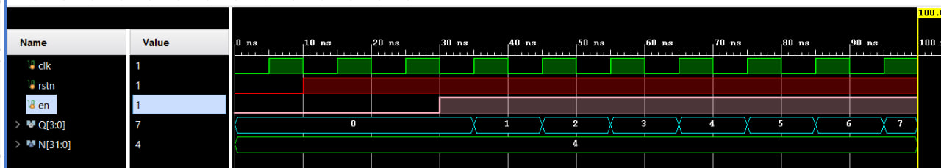

Task #8.3

8.3.1

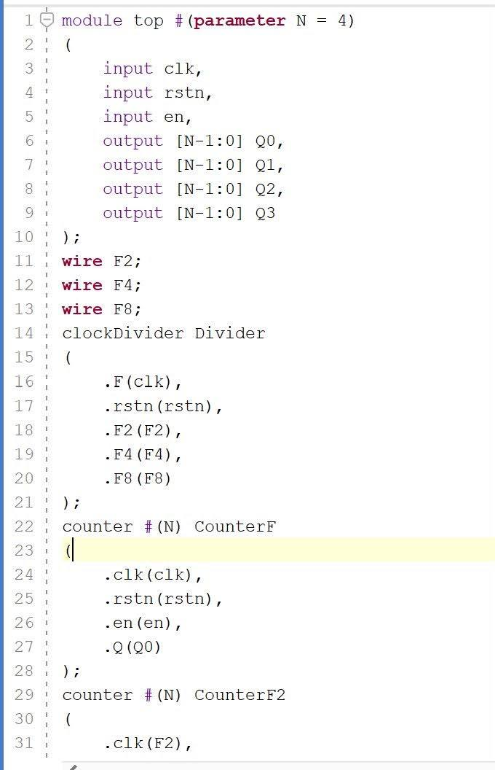

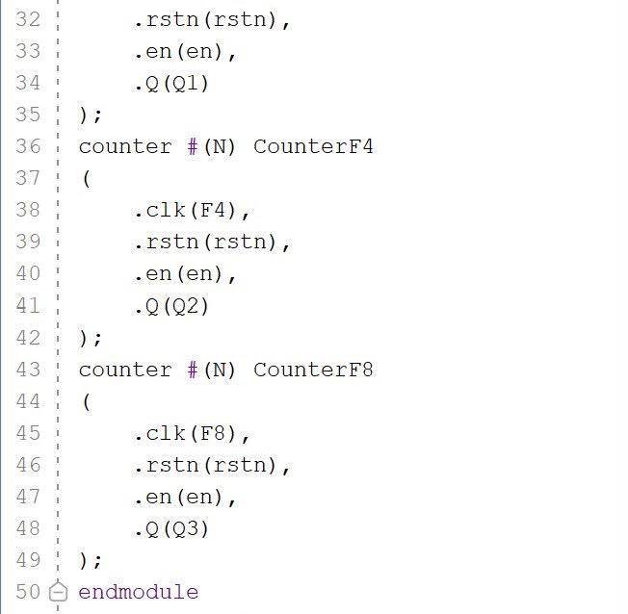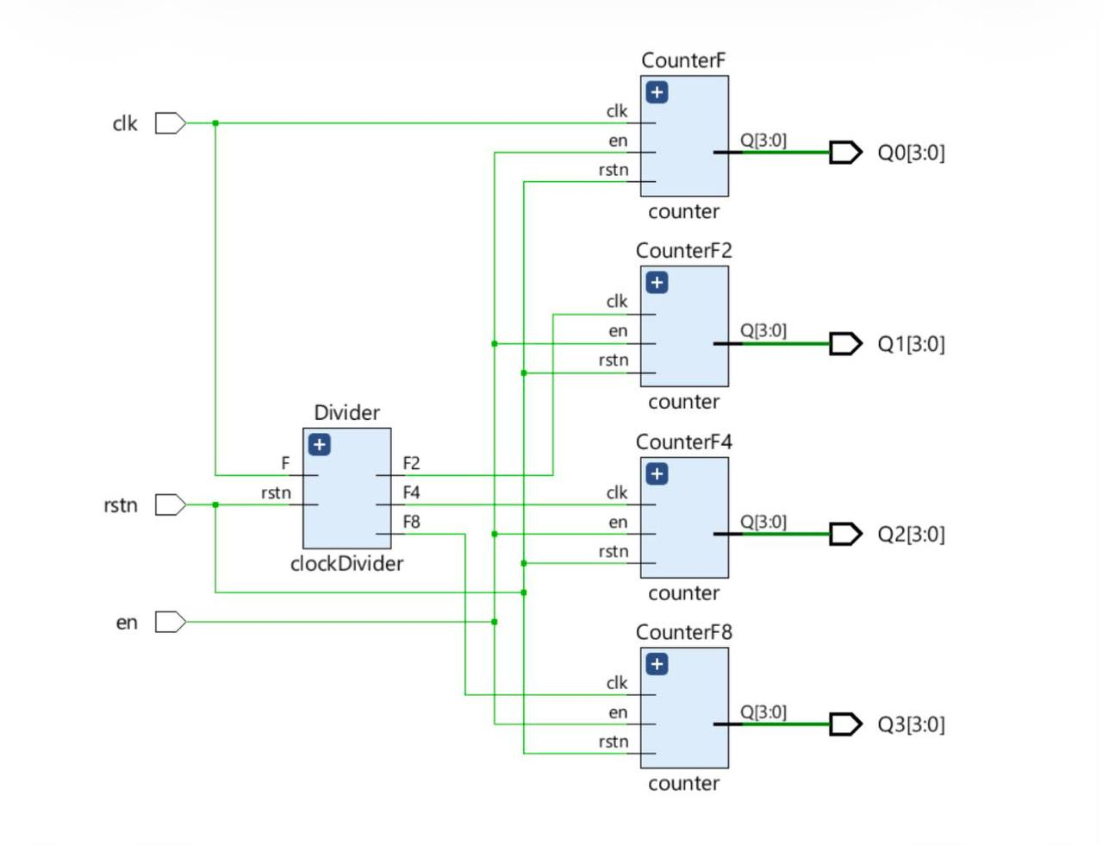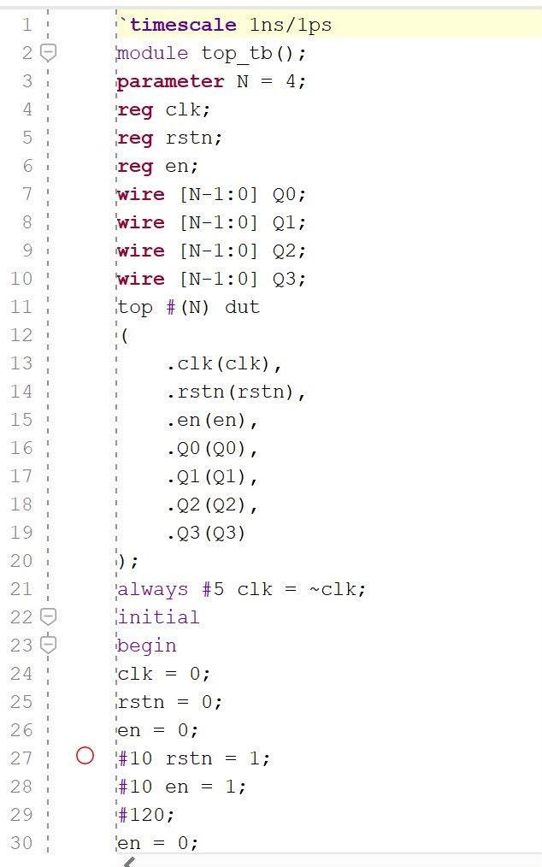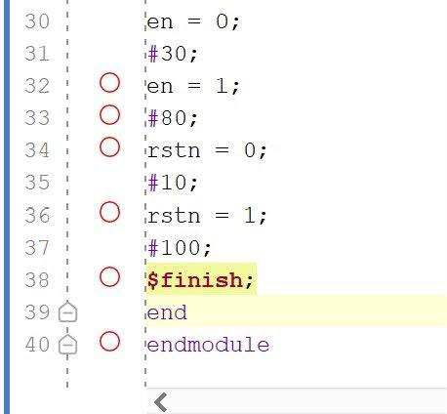

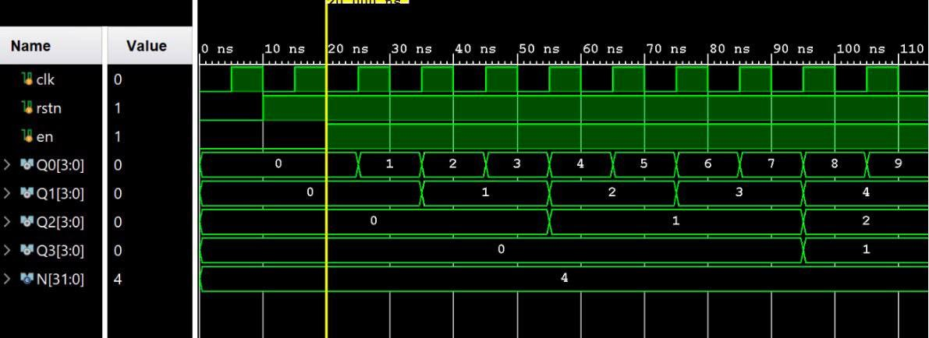

Work distribution

Section | Alia | Elaf | Lana | Manar
Report | ✔ | ✔ | ✔ | ✔
Task n.x | ✔ | ✔ | ✔ | ✔
Task n.x+1 | ✔ | ✔ | ✔ | ✔
Task | ✔ | ✔ | ✔ | ✔

